NEPAL COLLEGE OF INFORMATION TECHNOLOGY
Pokhara University
LAB REPORT
Frequency Division Multiplexing (FDM) and Demultiplexing using MATLAB
Course | Data Communication (CMP-335)
Experiment No. | 4
Experiment Title | Frequency Division Multiplexing (FDM) using MATLAB
Name | Suraj Kumar Jha
Roll No. | 231537
Program | B.E. Information Technology, 6th Semester

1. Objective
- To understand the principle of Frequency Division Multiplexing (FDM) and generate a composite FDM signal from multiple message signals in MATLAB.
- To modulate each message signal onto a distinct carrier frequency using amplitude modulation and combine them into a single composite signal.
- To separate (demultiplex) the individual channels from the composite signal using bandpass filtering, demodulation, and low-pass filtering.
- To verify successful recovery of each message signal by comparing the recovered signals and their spectra with the originals.

2. Theory
Frequency Division Multiplexing (FDM) is an analog multiplexing technique that allows multiple message signals to share a single communication channel simultaneously by assigning each signal a distinct, non-overlapping frequency band. Each message signal is used to modulate a separate carrier of a different frequency, and the resulting modulated signals are added together to form one composite signal that occupies the combined bandwidth of all channels. Because the channels occupy separate frequency slots, they can later be separated at the receiver using filters, without interfering with one another.

2.1 Message and Carrier Signals
In this experiment, three low-frequency message (baseband) signals of different amplitudes and frequencies represent three independent sources of information. Each message signal is multiplied by a distinct high-frequency carrier signal, which shifts (modulates) the message signal's spectrum up to a location centered on the carrier frequency. Choosing carrier frequencies that are sufficiently far apart, relative to the message bandwidths, ensures that the frequency bands of the three modulated signals do not overlap.

2.2 Composite FDM Signal Generation
The composite FDM signal is formed by summing the three amplitude-modulated signals:
x(t) = m1(t)·c1(t) + m2(t)·c2(t) + m3(t)·c3(t)
In the frequency domain, this composite signal contains three separate pairs of spectral components, each pair centered around one of the carrier frequencies (±fc1, ±fc2, ±fc3), which is the defining characteristic of FDM.

2.3 Channel Separation — Bandpass Filtering
To recover an individual channel from the composite signal, a bandpass filter centered on that channel's carrier frequency is used to isolate the relevant frequency band while rejecting the other two channels. In this experiment, a 5th-order Butterworth bandpass filter is designed around each carrier frequency, with a passband wide enough to include the message signal's sidebands (fc ± (fm + guard band)).

2.4 Demodulation and Low-Pass Filtering
After bandpass filtering, the isolated channel is demodulated by multiplying it again with the same carrier signal used at the transmitter (coherent/synchronous detection). This mixing operation shifts the desired message signal back down to baseband, but also produces an unwanted high-frequency component near twice the carrier frequency. A low-pass filter, with a cutoff frequency just above the message bandwidth, is then applied to remove this high-frequency component and recover the original baseband message signal.

2.5 Advantages and Applications of FDM
FDM allows efficient simultaneous use of a shared transmission medium by multiple signals, without time-sharing delays, and is conceptually simple to implement with analog filters and mixers. It has historically been used in applications such as analog telephone trunk systems, radio and television broadcasting, and cable television distribution, where multiple channels are transmitted over a common medium at different carrier frequencies.

3. Apparatus / Software Used
- MATLAB (R2023a or equivalent) with the Signal Processing Toolbox functions butter() and filter().
- A computer system capable of running MATLAB.

4. Signal Parameters
Channel | Am (V) | fm (Hz) | Cm (V) | fc (Hz)
1 | 2 | 4 | 1 | 100
2 | 3 | 5 | 1 | 170
3 | 4 | 6 | 1 | 250
Sampling frequency fs = 4001 Hz; observation window t = 0 to 1 second.

5. Procedure
- Define the sampling frequency and time vector, and generate three cosine message signals (m1, m2, m3) with the amplitudes and frequencies listed above.
- Generate three cosine carrier signals (c1, c2, c3) with widely separated carrier frequencies (100 Hz, 170 Hz, 250 Hz).
- Modulate each message signal by multiplying it with its corresponding carrier, and sum the three products to form the composite FDM signal x(t).
- Plot the message signals and carrier signals in the time domain, and their magnitude spectra (via FFT) in the frequency domain.
- Plot the composite FDM signal in both the time domain and the frequency domain, and verify that three distinct frequency bands are visible, centered on the three carrier frequencies.
- Design a 5th-order Butterworth bandpass filter around each carrier frequency and apply it to the composite signal to isolate each channel.
- Demodulate each isolated channel by multiplying it with its original carrier signal.
- Apply a 5th-order Butterworth low-pass filter to each demodulated signal to remove the high-frequency mixing component and recover the baseband message signal.
- Plot the recovered signals in the time domain and their spectra in the frequency domain, and compare them with the original message signals.

6. MATLAB Code
clc;
clear;
close all;

%% ==========================================================
% MESSAGE SIGNAL GENERATION
%% ==========================================================
fs = 4001; % Sampling Frequency
t = 0:1/fs:1-1/fs; % Time vector

Am1 = 2; fm1 = 4; m1 = Am1*cos(2*pi*fm1*t); % Message Signal 1
Am2 = 3; fm2 = 5; m2 = Am2*cos(2*pi*fm2*t); % Message Signal 2
Am3 = 4; fm3 = 6; m3 = Am3*cos(2*pi*fm3*t); % Message Signal 3

%% ==========================================================
% CARRIER SIGNAL GENERATION
%% ==========================================================
Cm1 = 1; fc1 = 100; c1 = Cm1*cos(2*pi*fc1*t); % Carrier Signal 1
Cm2 = 1; fc2 = 170; c2 = Cm2*cos(2*pi*fc2*t); % Carrier Signal 2
Cm3 = 1; fc3 = 250; c3 = Cm3*cos(2*pi*fc3*t); % Carrier Signal 3

%% ==========================================================
% COMPOSITE FDM SIGNAL GENERATION
%% ==========================================================
x = (m1 .* c1) + (m2 .* c2) + (m3 .* c3);

%% ==========================================================
% MESSAGE SIGNALS (TIME DOMAIN)
%% ==========================================================
figure;
subplot(3,1,1); plot(t,m1); xlabel('Time (s)'); ylabel('Amplitude');
title('Message Signal 1'); ylim([-Am1 Am1])
subplot(3,1,2); plot(t,m2); xlabel('Time (s)'); ylabel('Amplitude');
title('Message Signal 2'); ylim([-Am2 Am2])
subplot(3,1,3); plot(t,m3); xlabel('Time (s)'); ylabel('Amplitude');
title('Message Signal 3'); ylim([-Am3 Am3])
exportgraphics(gcf,'Figure1_MessageSignals.png','Resolution',300);

%% ==========================================================
% FREQUENCY DOMAIN ANALYSIS
%% ==========================================================
M1 = abs(fftshift(fft(m1)))/(fs/2);
M2 = abs(fftshift(fft(m2)))/(fs/2);
M3 = abs(fftshift(fft(m3)))/(fs/2);
X = abs(fftshift(fft(x)))/(fs/2);
f = fs/2 * linspace(-1,1,fs);

%% ==========================================================
% MESSAGE SIGNALS (FREQUENCY DOMAIN)
%% ==========================================================
figure;
subplot(3,1,1); stem(f,M1); xlabel('Frequency (Hz)'); ylabel('Amplitude');
title('Message Signal 1 Spectrum'); axis([-10 10 0 2.5])
subplot(3,1,2); stem(f,M2); xlabel('Frequency (Hz)'); ylabel('Amplitude');
title('Message Signal 2 Spectrum'); axis([-10 10 0 3.5])
subplot(3,1,3); stem(f,M3); xlabel('Frequency (Hz)'); ylabel('Amplitude');
title('Message Signal 3 Spectrum'); axis([-10 10 0 4.5])
exportgraphics(gcf,'Figure2_MessageSpectrum.png','Resolution',300);

%% ==========================================================
% CARRIER SIGNALS (TIME DOMAIN)
%% ==========================================================
figure;
subplot(3,1,1); plot(t,c1); xlabel('Time (s)'); ylabel('Amplitude');
title('Carrier Signal 1'); ylim([-Cm1 Cm1])
subplot(3,1,2); plot(t,c2); xlabel('Time (s)'); ylabel('Amplitude');
title('Carrier Signal 2'); ylim([-Cm2 Cm2])
subplot(3,1,3); plot(t,c3); xlabel('Time (s)'); ylabel('Amplitude');
title('Carrier Signal 3'); ylim([-Cm3 Cm3])
exportgraphics(gcf,'Figure3_CarrierSignals.png','Resolution',300);

%% ==========================================================
% CARRIER SIGNALS (FREQUENCY DOMAIN)
%% ==========================================================
C1 = abs(fftshift(fft(c1)))/(fs/2);
C2 = abs(fftshift(fft(c2)))/(fs/2);
C3 = abs(fftshift(fft(c3)))/(fs/2);

figure;
subplot(3,1,1); stem(f,C1); xlabel('Frequency (Hz)'); ylabel('Amplitude');
title('Carrier Signal 1 Spectrum'); axis([-120 120 0 1.2])
subplot(3,1,2); stem(f,C2); xlabel('Frequency (Hz)'); ylabel('Amplitude');
title('Carrier Signal 2 Spectrum'); axis([-200 200 0 1.2])
subplot(3,1,3); stem(f,C3); xlabel('Frequency (Hz)'); ylabel('Amplitude');
title('Carrier Signal 3 Spectrum'); axis([-300 300 0 1.2])
exportgraphics(gcf,'Figure4_CarrierSpectrum.png','Resolution',300);

%% ==========================================================
% COMPOSITE FDM SIGNAL
%% ==========================================================
figure;
subplot(2,1,1); plot(t,x); xlabel('Time (s)'); ylabel('Amplitude');
title('Composite FDM Signal (Time Domain)')
subplot(2,1,2); stem(f,X); xlabel('Frequency (Hz)'); ylabel('Amplitude');
title('Composite FDM Signal (Frequency Domain)')
exportgraphics(gcf,'Figure5_CompositeFDM.png','Resolution',300);

%% ==========================================================
% BANDPASS FILTERING
%% ==========================================================
[num1, den1] = butter(5,[(fc1-fm1-6)/(fs/2),(fc1+fm1+6)/(fs/2)]);
bpf1 = filter(num1,den1,x);
[num2, den2] = butter(5,[(fc2-fm2-6)/(fs/2),(fc2+fm2+6)/(fs/2)]);
bpf2 = filter(num2,den2,x);
[num3, den3] = butter(5,[(fc3-fm3-6)/(fs/2),(fc3+fm3+6)/(fs/2)]);
bpf3 = filter(num3,den3,x);

%% ==========================================================
% DEMODULATION (MIXING)
%% ==========================================================
z1 = 2*bpf1.*c1;
z2 = 2*bpf2.*c2;
z3 = 2*bpf3.*c3;

%% ==========================================================
% LOW PASS FILTERING
%% ==========================================================
[num4,den4] = butter(5,(fm1+3)/(fs/2));
rec1 = filter(num4,den4,z1);
[num5,den5] = butter(5,(fm2+3)/(fs/2));
rec2 = filter(num5,den5,z2);
[num6,den6] = butter(5,(fm3+3)/(fs/2));
rec3 = filter(num6,den6,z3);

%% ==========================================================
% RECOVERED SIGNALS (TIME DOMAIN)
%% ==========================================================
figure;
subplot(3,1,1); plot(t,rec1); xlabel('Time (s)'); ylabel('Amplitude');
title('Recovered Signal 1'); ylim([-Am1 Am1])
subplot(3,1,2); plot(t,rec2); xlabel('Time (s)'); ylabel('Amplitude');
title('Recovered Signal 2'); ylim([-Am2 Am2])
subplot(3,1,3); plot(t,rec3); xlabel('Time (s)'); ylabel('Amplitude');
title('Recovered Signal 3'); ylim([-Am3 Am3])
exportgraphics(gcf,'Figure6_RecoveredSignals.png','Resolution',300);

%% ==========================================================
% RECOVERED SIGNALS (FREQUENCY DOMAIN)
%% ==========================================================
R1 = abs(fftshift(fft(rec1)))/(fs/2);
R2 = abs(fftshift(fft(rec2)))/(fs/2);
R3 = abs(fftshift(fft(rec3)))/(fs/2);

figure;
subplot(3,1,1); stem(f,R1); xlabel('Frequency (Hz)'); ylabel('Amplitude');
title('Recovered Signal 1 Spectrum'); xlim([-10 10])
subplot(3,1,2); stem(f,R2); xlabel('Frequency (Hz)'); ylabel('Amplitude');
title('Recovered Signal 2 Spectrum'); xlim([-10 10])
subplot(3,1,3); stem(f,R3); xlabel('Frequency (Hz)'); ylabel('Amplitude');
title('Recovered Signal 3 Spectrum'); xlim([-10 10])
exportgraphics(gcf,'Figure7_RecoveredSpectrum.png','Resolution',300);

%% ==========================================================
% END OF PROGRAM
%% ==========================================================
disp('All figures have been exported successfully!');

7. Results
The MATLAB program was executed successfully, producing the message signals, carrier signals, composite FDM signal, and the recovered signals after demultiplexing.
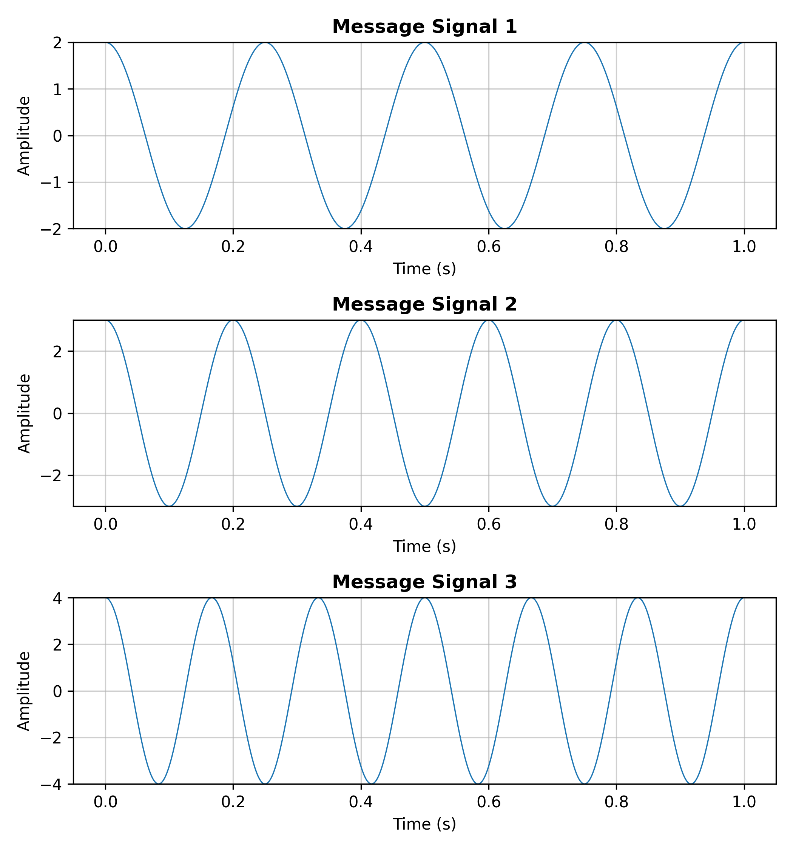
Figure 1: Message Signals m1, m2, m3 (Time Domain)
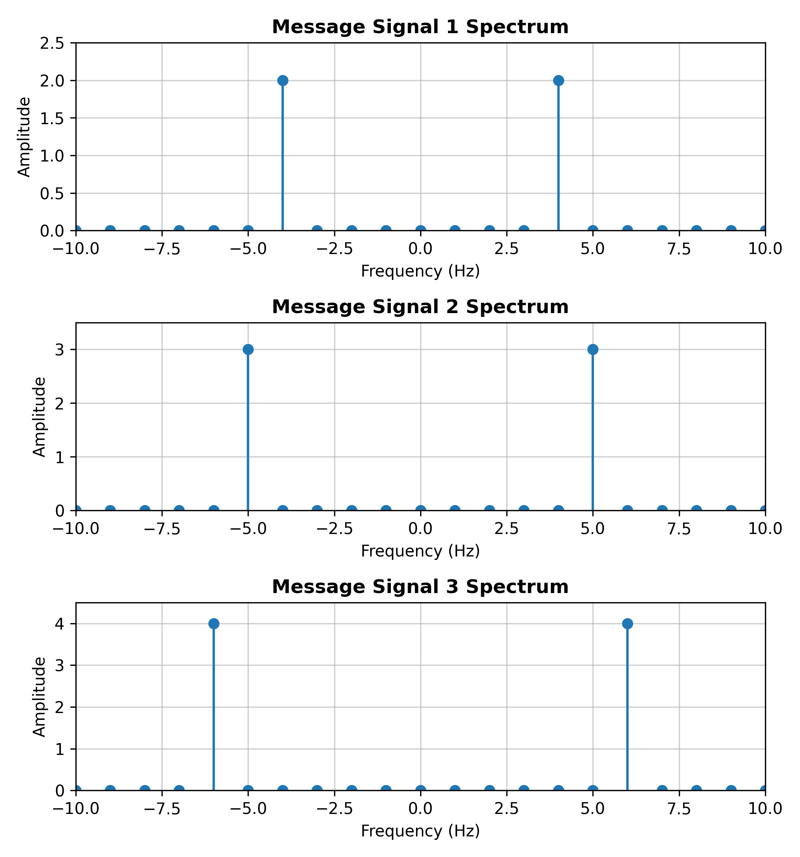
Figure 2: Message Signal Spectra
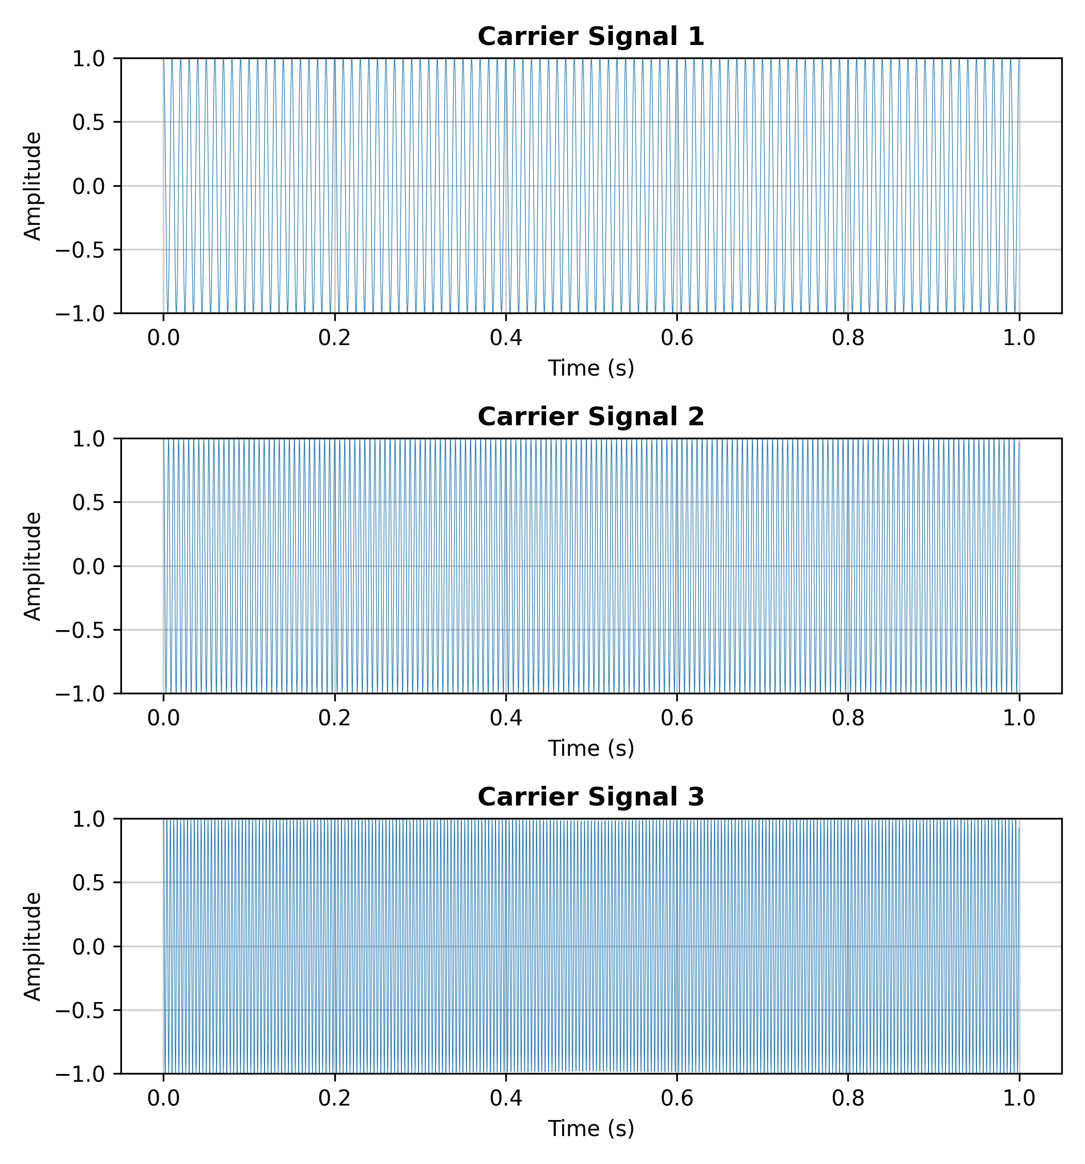
Figure 3: Carrier Signals c1, c2, c3 (Time Domain)
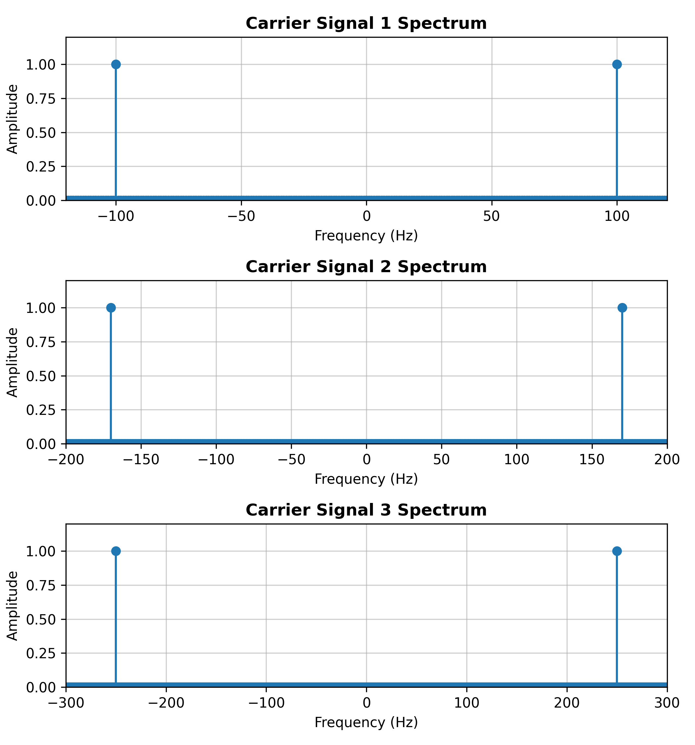
Figure 4: Carrier Signal Spectra
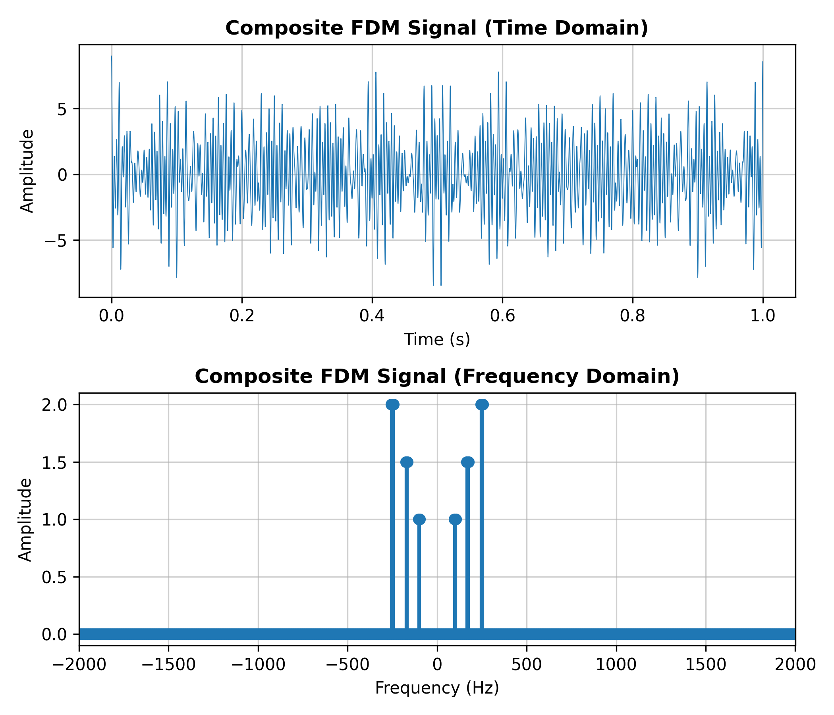
Figure 5: Composite FDM Signal — Time Domain and Frequency Domain
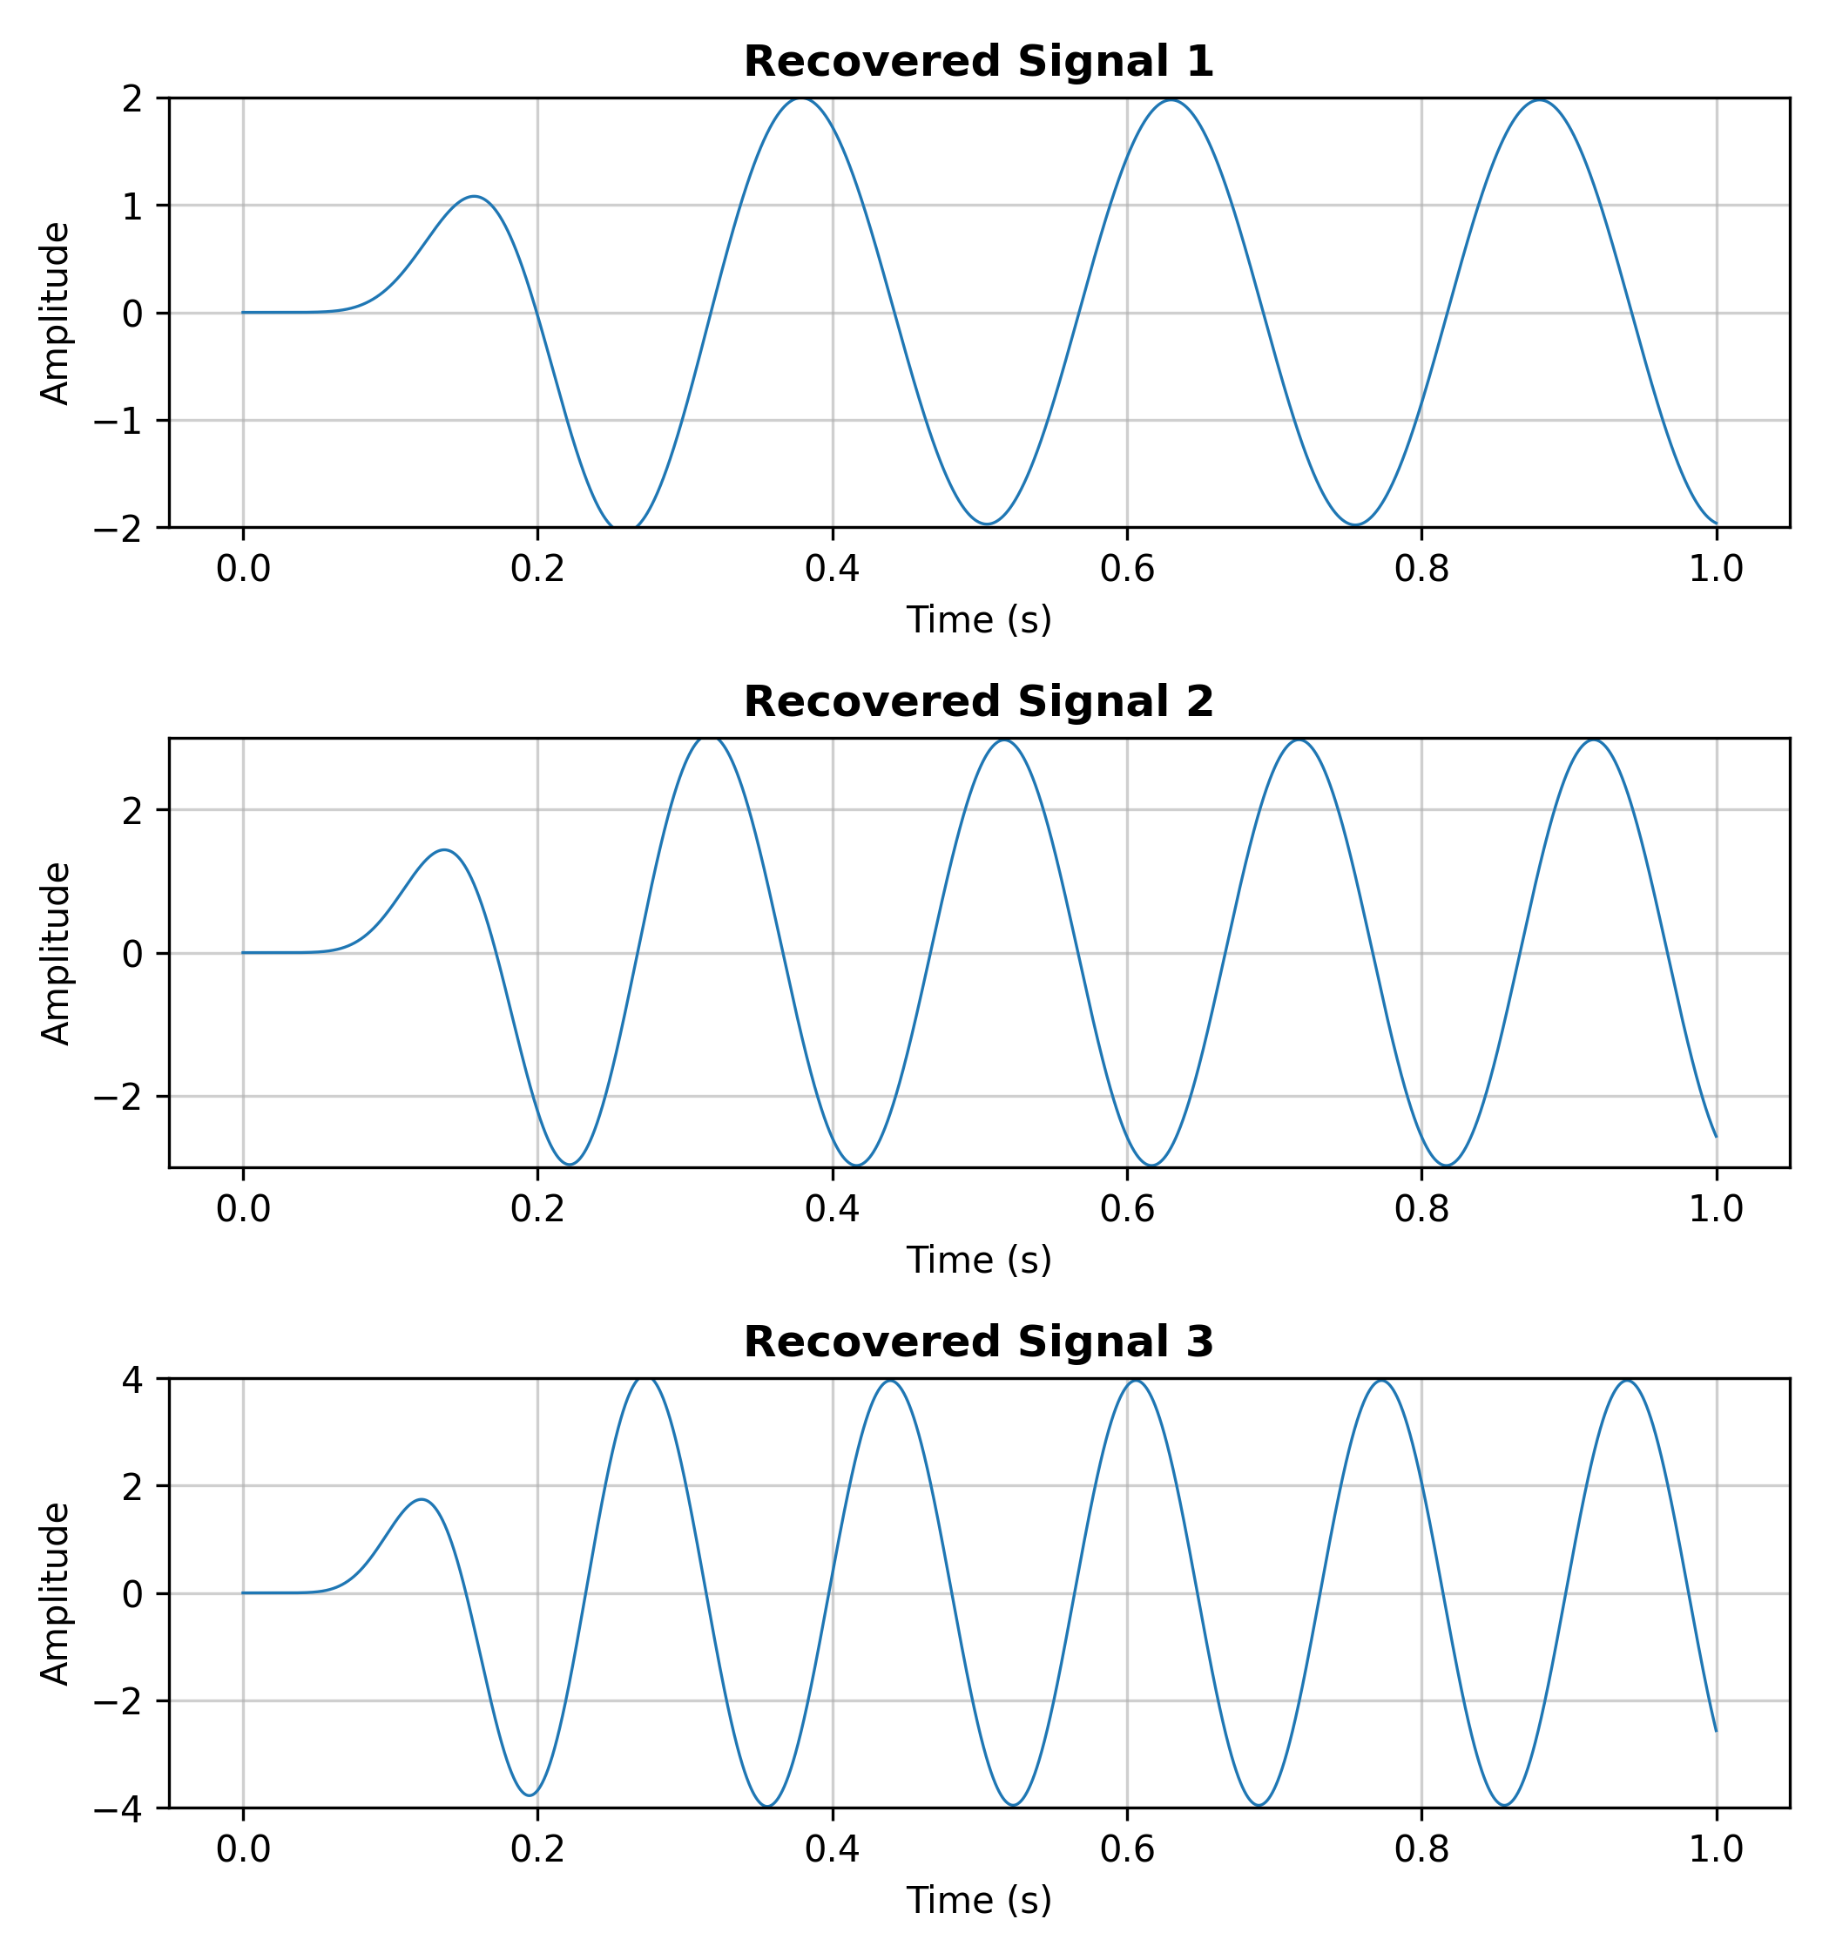
Figure 6: Recovered (Demultiplexed) Signals
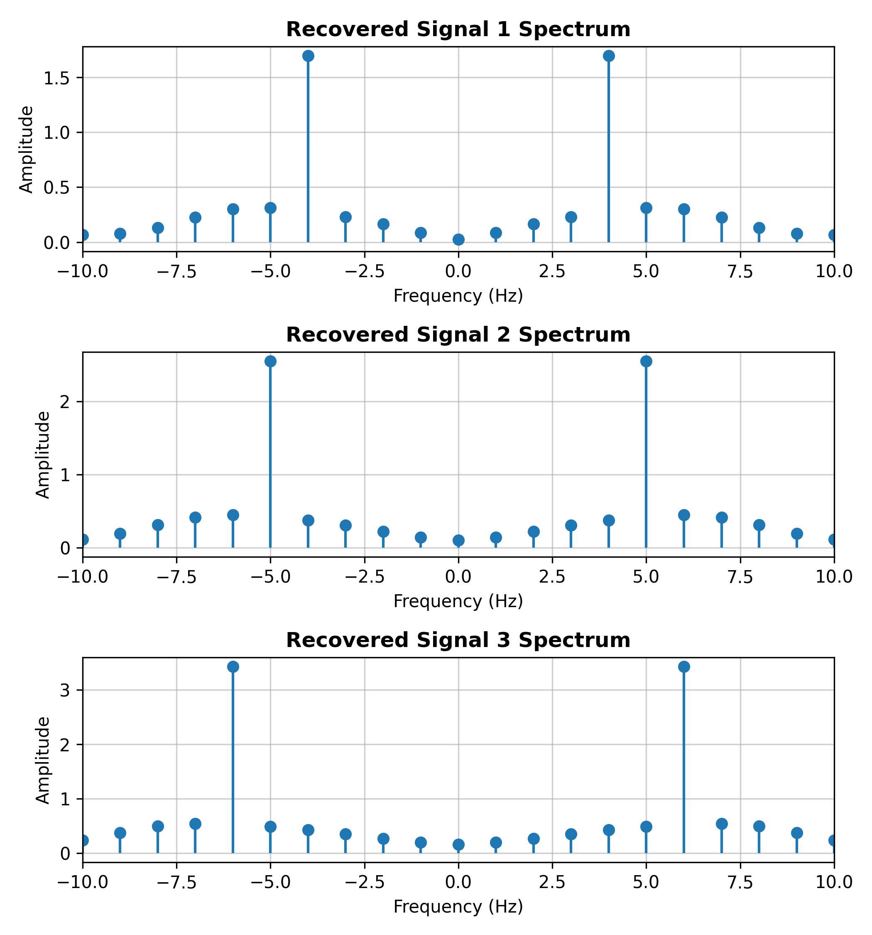
Figure 7: Recovered Signal Spectra

8. Discussion
Figures 1 and 2 show the three message signals and their narrowband spectra, each with a single pair of spectral lines at ±fm. Figures 3 and 4 show the corresponding carriers, whose spectra consist of sharp lines at ±fc1, ±fc2, and ±fc3. When these are multiplied together and summed, Figure 5 shows that the resulting composite FDM signal occupies three separate, non-overlapping frequency bands in the spectrum, each centered on one carrier frequency — confirming that FDM successfully packs three independent signals into a single composite waveform without spectral overlap.
At the receiver side, each channel was isolated with a bandpass filter tuned around its own carrier frequency, demodulated by remixing with the same carrier, and low-pass filtered to remove the resulting high-frequency image. Figures 6 and 7 show that the recovered signals closely reproduce the shape, amplitude, and frequency of the original message signals (allowing for a brief transient at the start caused by the filters settling), and their spectra again show single narrowband peaks near ±fm, matching the original message spectra in Figure 2. This confirms that the bandpass filtering, demodulation, and low-pass filtering stages together successfully demultiplexed and recovered each channel from the shared composite signal.

9. Conclusion
In this experiment, Frequency Division Multiplexing was successfully implemented in MATLAB by modulating three message signals onto three separate carrier frequencies and combining them into one composite signal. The individual channels were subsequently recovered using bandpass filtering, coherent demodulation, and low-pass filtering, and the recovered signals closely matched the original message signals in both the time and frequency domains. This confirms the practical feasibility of FDM as a technique for sharing a single communication channel among multiple signals by allocating each a distinct frequency band.

